Chapter 2
Introduction to supervised Learning
Classification Problems
Linear Regression
Decision tree representation
Support vector machine (SVM)

Classification
In machine learning, classification refers to a predictive modeling problem where a class label is predicted for a given example of input data.
- The goal of classification is to use an object's characteristics to identify which class (or group) it belongs to.
- A linear classifier achieves this by making a classification decision based on the value of a linear combination of the characteristics.
- An object's characteristics are also known as feature values and are typically presented to the machine in a vector called a feature vector.
- Such classifiers work well for practical problems such as document classification, and more generally for problems with many variables (features), reaching accuracy levels comparable to non-linear classifiers while taking less time to train and use.

Examples of classification problems include:
- Given an example, classify if it is spam or not.
- Given a handwritten character, classify it as one of the known characters.
- Given recent user behavior, classify as churn or not.
From a modeling perspective, classification requires a training dataset with many examples of inputs and outputs from which to learn.
A model will use the training dataset and will calculate how to best map examples of input data to specific class labels. As such, the training dataset must be sufficiently representative of the problem and have many examples of each class label.
Class labels are often string values, e.g. “spam,” “not spam,” and must be mapped to numeric values before being provided to an algorithm for modeling. This is often referred to as label encoding, where a unique integer is assigned to each class label, e.g. “spam” = 0, “no spam” = 1.
There are many different types of classification algorithms for modeling classification predictive modeling problems.
There is no good theory on how to map algorithms onto problem types; instead, it is generally recommended that a practitioner use controlled experiments and discover which algorithm and algorithm configuration results in the best performance for a given classification task.
Classification predictive modeling algorithms are evaluated based on their results. Classification accuracy is a popular metric used to evaluate the performance of a model based on the predicted class labels. Classification accuracy is not perfect but is a good starting point for many classification tasks.
Instead of class labels, some tasks may require the prediction of a probability of class membership for each example. This provides additional uncertainty in the prediction that an application or user can then interpret. A popular diagnostic for evaluating predicted probabilities is the ROC Curve.

What is the Classification Algorithm?
The Classification algorithm is a Supervised Learning technique that is used to identify the category of new observations on the basis of training data. In Classification, a program learns from the given dataset or observations and then classifies new observation into a number of classes or groups. Such as, Yes or No, 0 or 1, Spam or Not Spam, cat or dog, etc. Classes can be called as targets/labels or categories.
Unlike regression, the output variable of Classification is a category, not a value, such as "Green or Blue", "fruit or animal", etc. Since the Classification algorithm is a Supervised learning technique, hence it takes labeled input data, which means it contains input with the corresponding output.
In classification algorithm, a discrete output function(y) is mapped to input variable(x).
y=f(x), where y = categorical output

The best example of an ML classification algorithm is Email Spam Detector.
The main goal of the Classification algorithm is to identify the category of a given dataset, and these algorithms are mainly used to predict the output for the categorical data.
Classification algorithms can be better understood using the below diagram. In the below diagram, there are two classes, class A and Class B. These classes have features that are similar to each other and dissimilar to other classes.
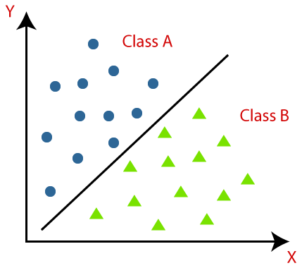
The algorithm which implements the classification on a dataset is known as a classifier. There are two types of Classifications:
- Binary Classifier: If the classification problem has only two possible outcomes, then it is called as Binary Classifier.
Examples: YES or NO, MALE or FEMALE, SPAM or NOT SPAM, CAT or DOG, etc.
- Multi-class Classifier: If a classification problem has more than two outcomes, then it is called as Multi-class Classifier.
Example: Classifications of types of crops, Classification of types of music.

Learners in Classification Problems:
In the classification problems, there are two types of learners:
Lazy Learners: Lazy Learner firstly stores the training dataset and wait until it receives the test dataset. In Lazy learner case, classification is done on the basis of the most related data stored in the training dataset. It takes less time in training but more time for predictions.
Example: K-NN algorithm, Case-based reasoning
- Eager Learners: Eager Learners develop a classification model based on a training dataset before receiving a test dataset. Opposite to Lazy learners, Eager Learner takes more time in learning, and less time in prediction. Example: Decision Trees, Naïve Bayes, ANN.

Types of ML Classification Algorithms:
Classification Algorithms can be further divided into the Mainly two category:
- Linear Models
  - Logistic Regression
  - Support Vector Machines
- Non-linear Models
  - K-Nearest Neighbours
  - Kernel SVM
  - Naïve Bayes
  - Decision Tree Classification
  - Random Forest Classification

Use cases of Classification Algorithms
Classification algorithms can be used in different places. Below are some popular use cases of Classification Algorithms:
- Email Spam Detection
- Speech Recognition
- Identifications of Cancer tumor cells.
- Drugs Classification
- Biometric Identification, etc.

Regression Analysis in Machine learning
Regression analysis is a statistical method to model the relationship between a dependent (target) and independent (predictor) variables with one or more independent variables. More specifically, Regression analysis helps us to understand how the value of the dependent variable is changing corresponding to an independent variable when other independent variables are held fixed. It predicts continuous/real values such as temperature, age, salary, price, etc.
We can understand the concept of regression analysis using the below example:
Example: Suppose there is a marketing company A, who does various advertisement every year and get sales on that. The below list shows the advertisement made by the company in the last 5 years and the corresponding sales:
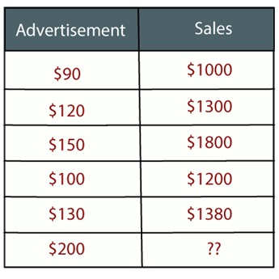
Now, the company wants to do the advertisement of $200 in the year 2019 and wants to know the prediction about the sales for this year. So to solve such type of prediction problems in machine learning, we need regression analysis.
C++ vs Java
Regression is a supervised learning technique which helps in finding the correlation between variables and enables us to predict the continuous output variable based on the one or more predictor variables. It is mainly used for prediction, forecasting, time series modeling, and determining the causal-effect relationship between variables.
In Regression, we plot a graph between the variables which best fits the given datapoints, using this plot, the machine learning model can make predictions about the data. In simple words, "Regression shows a line or curve that passes through all the datapoints on target-predictor graph in such a way that the vertical distance between the datapoints and the regression line is minimum." The distance between datapoints and line tells whether a model has captured a strong relationship or not.
Some examples of regression can be as:
- Prediction of rain using temperature and other factors
- Determining Market trends
- Prediction of road accidents due to rash driving.

Terminologies Related to the Regression Analysis:
- Dependent Variable: The main factor in Regression analysis which we want to predict or understand is called the dependent variable. It is also called target variable.
- Independent Variable: The factors which affect the dependent variables or which are used to predict the values of the dependent variables are called independent variable, also called as a predictor.
- Outliers: Outlier is an observation which contains either very low value or very high value in comparison to other observed values. An outlier may hamper the result, so it should be avoided.
- Multicollinearity: If the independent variables are highly correlated with each other than other variables, then such condition is called Multicollinearity. It should not be present in the dataset, because it creates problem while ranking the most affecting variable.
- Underfitting and Overfitting: If our algorithm works well with the training dataset but not well with test dataset, then such problem is called Overfitting. And if our algorithm does not perform well even with training dataset, then such problem is called underfitting.

Why do we use Regression Analysis?
As mentioned above, Regression analysis helps in the prediction of a continuous variable. There are various scenarios in the real world where we need some future predictions such as weather condition, sales prediction, marketing trends, etc., for such case we need some technology which can make predictions more accurately. So for such case we need Regression analysis which is a statistical method and used in machine learning and data science. Below are some other reasons for using Regression analysis:
- Regression estimates the relationship between the target and the independent variable.
- It is used to find the trends in data.
- It helps to predict real/continuous values.
- By performing the regression, we can confidently determine the most important factor, the least important factor, and how each factor is affecting the other factors.

Types of Regression
There are various types of regressions which are used in data science and machine learning. Each type has its own importance on different scenarios, but at the core, all the regression methods analyze the effect of the independent variable on dependent variables. Here we are discussing some important types of regression which are given below:
- Linear Regression
- Logistic Regression
- Polynomial Regression
- Support Vector Regression
- Decision Tree Regression
- Random Forest Regression
- Ridge Regression
- Lasso Regression:
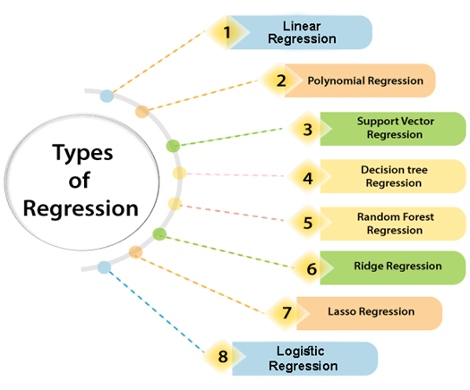

Linear Regression:
- Linear regression is a statistical regression method which is used for predictive analysis.
- It is one of the very simple and easy algorithms which works on regression and shows the relationship between the continuous variables.
- It is used for solving the regression problem in machine learning.
- Linear regression shows the linear relationship between the independent variable (X-axis) and the dependent variable (Y-axis), hence called linear regression.
- If there is only one input variable (x), then such linear regression is called simple linear regression. And if there is more than one input variable, then such linear regression is called multiple linear regression.
- The relationship between variables in the linear regression model can be explained using the below image. Here we are predicting the salary of an employee on the basis of the year of experience.
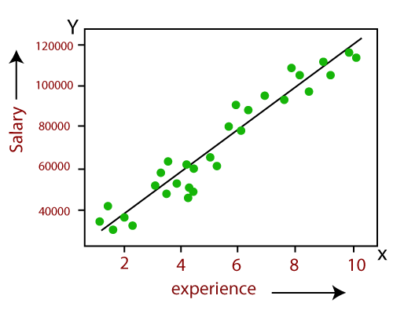
- Below is the mathematical equation for Linear regression:
- Y= aX+b
Here, Y = dependent variables (target variables),
X= Independent variables (predictor variables),
a and b are the linear coefficients
Linear Regression is one of the most important algorithms in machine learning. It is the statistical way of measuring the relationship between one or more independent variables vs one dependent variable.
The Linear Regression model attempts to find the relationship between variables by finding the Best Fit Line.
Let’s learn about how the model finds the best fit line and how to measure the goodness of fit in this article in detail

Simple Linear Regression
Simple Linear Regression is the linear regression model with one independent variable and one dependent variable.
Example: Years of Experience vs Salary, Area vs House Price
Before building a simple linear regression model, we have to check the linear relationship between the two variables.
We can measure the strength of the linear relationship, by using a correlation coefficient.

Correlation Coefficient
It is the measure of linear association between two variables. It determines the strength of linear association and its direction.
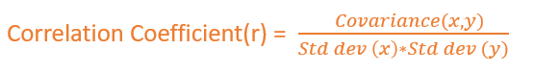
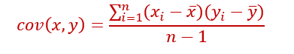
Covariance checks how the two variables vary together.
Covariance depends on units of x and y. Covariance ranges from -∞ to + ∞.
But Correlation coefficient is unit-free. It is just a number.
Coefficient Correlation r ranges from -1 to +1
- If r=0 → It means there is no linear relationship. It doesn’t mean that there is no relationship
- r will be negative if one variable increases, other variable decreases.
- r will be positive, if one variable increases, the other variable also increases.
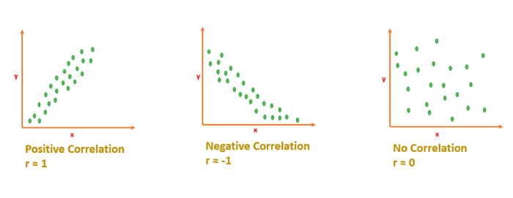

Interpreting Correlation Coefficient
If r is close to 1 or -1 means, x and y are strongly correlated.
If r is close to 0 means, x and y are not correlated. [No linear relationship]

Visualizing Correlation
Example: “Years of experience” Vs “Salary”. Here we want to predict the salary for a given ‘Year of experience’.
Salary → dependent variable
Years_of_Experience →Independent Variable.
- Scatterplot to visualize the correlation
df=pd.read_csv('salary.csv')
sns.scatterplot(x='Years_Of_Exp',y='Salary',data=df,color='darkorange')

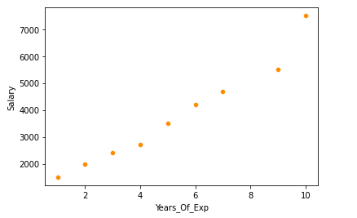
2. Exact r value -heatmap
sns.heatmap(df.corr(),annot=True)

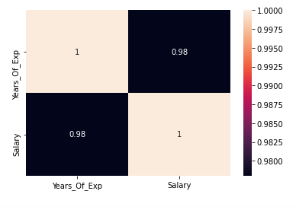
r is 0.98 → It indicates both the variables are strongly correlated.

The Best Fit Line
After finding the correlation between the variables[independent variable and target variable], and if the variables are linearly correlated, we can proceed with the Linear Regression model.
The Linear Regression model will find out the best fit line for the data points in the scatter cloud.
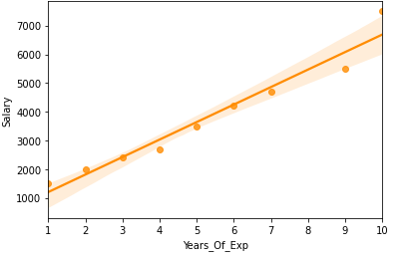
Let’s learn how to find the best fit line.

Equation of Straight Line
y=mx+c
m →slope
c →intercept
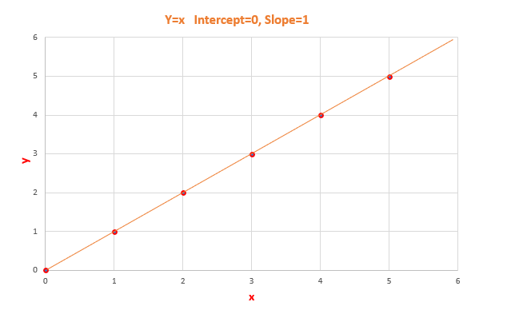
y=x [Slope=1, Intercept=0] -

Model Coefficient
Slope m and Intercept c are model coefficient/model parameters/regression coefficients.

Slope →m
Slope basically says how steep the line is. The slope is calculated by a change in y divided by a change in x
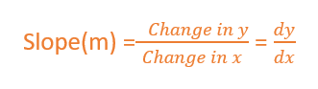
The slope will be negative if one increases and the other one decreases.
The slope will be positive if x increases and y increases.
The value of slope will range from -∞ to + ∞.
[Since we didn’t normalize the value, the slope will depend on units. So, it can take any value from -∞ to + ∞]

Intercept → c
The value of y when x is 0.
When the straight line passes through the origin intercept is 0.
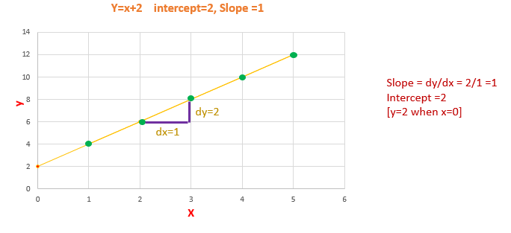
Calculating Slope and Intercept
The slope will remain constant for a line. We can calculate the slope by taking any two points in the straight line, by using the formula dy/dx.

Line of Best Fit
The Linear Regression model have to find the line of best fit.
We know the equation of a line is y=mx+c. There are infinite m and c possibilities, which one to chose?
Out of all possible lines, how to find the best fit line?
The line of best fit is calculated by using the cost function — Least Sum of Squares of Errors.
The line of best fit will have the least sum of squares error.

Cost Function
The least Sum of Squares of Errors is used as the cost function for Linear Regression.
For all possible lines, calculate the sum of squares of errors. The line which has the least sum of squares of errors is the best fit line.
Error/Residuals
Error is the difference between the actual value of y and the predicted value of y.
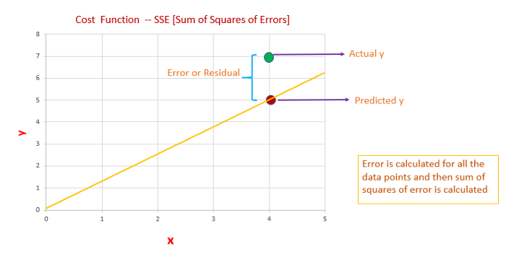
Error or Residual
- We have to calculate error/residual for all data points
- square the error/residuals.
- Then we have to calculate the sum of squares of all the errors.
- Out of all possible lines, the line which has the least sum of squares of errors is the line of best fit.

The reason behind squaring the error/residuals
- If we are not squaring the error, the negative and positive signs will cancel. We will end up with error=0
- So we are interested only in the magnitude of the error. How much the actual value deviates from the predicted value.
- So, why we didn’t consider the absolute value of error. Our motive is to find the least error. If the errors are squared, it will be easy to differentiate between the errors comparing to taking the absolute value of the error.
- Easier to differentiate the errors, it will be easier to identify the least sum of squares of error.
Out of all possible lines, the linear regression model comes up with the best fit line with the least sum of squares of error. Slope and Intercept of the best fit line are the model coefficient.
Now we have to measure how good is our best fit line?

Coefficient of Determination R² → R-squared
R-squared is one of the measures of goodness of the model. (best-fit line)
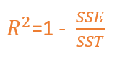
SSE →Sum of squares of Errors
SST →Sum of Squares Total
What is the Total Error?
Before building a linear regression model, we can say that the expected value of y is the mean/average value of y. The difference between the mean of y and the actual value of y is the Total Error.
Total Error is the Total variance. Total Variance is the amount of variance present in the data.
After building a linear regression model, our model predicts the y value. The difference between the mean of y and the predicted y value is the Regression Error.
Regression Error is the Explained Variance. Explained Variance means the amount of variance captured by the model.
Residual/Error is the difference between the actual y value and the predicted y value.
Residual/Error is the Unexplained Variance.
Total Error = Residual Error + Regression Error
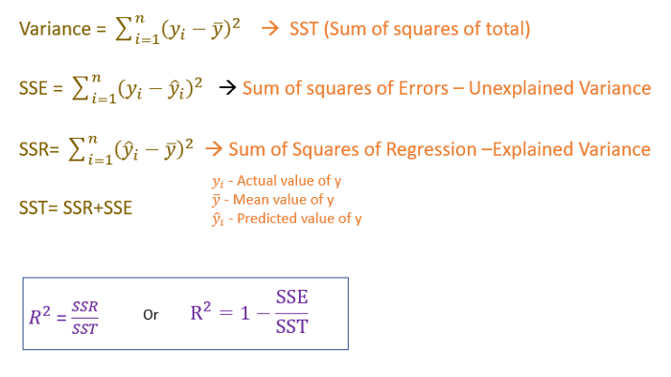
Image by Author
Coefficient of determination or R-squared measures how much variance in y is explained by the model.
The R-squared value ranges between 0 and 1
0 → being a bad model and 1 being good.
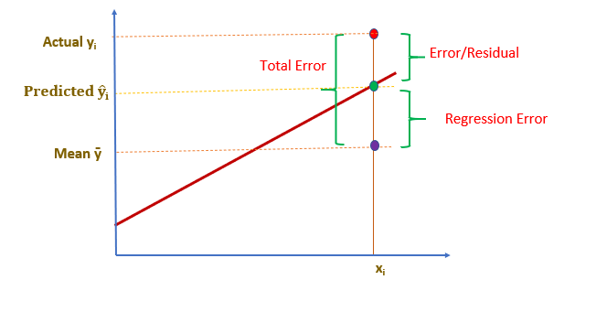
Image by Author

Key Takeaways
- Correlation Coefficient- r ranges from -1 to +1
- The coefficient of Determination- R² ranges from 0 to 1
- Slope and intercept are model coefficients or model parameters.

Some popular applications of linear regression are:
- Analyzing trends and sales estimates
- Salary forecasting
- Real estate prediction
- Arriving at ETAs in traffic.

Logistic Regression:
- Logistic regression is another supervised learning algorithm which is used to solve the classification problems. In classification problems, we have dependent variables in a binary or discrete format such as 0 or 1.
- Logistic regression algorithm works with the categorical variable such as 0 or 1, Yes or No, True or False, Spam or not spam, etc.
- It is a predictive analysis algorithm which works on the concept of probability.
- Logistic regression is a type of regression, but it is different from the linear regression algorithm in the term how they are used.
- Logistic regression uses sigmoid function or logistic function which is a complex cost function. This sigmoid function is used to model the data in logistic regression. The function can be represented as:
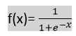
- f(x)= Output between the 0 and 1 value.
- x= input to the function
- e= base of natural logarithm.
When we provide the input values (data) to the function, it gives the S-curve as follows:
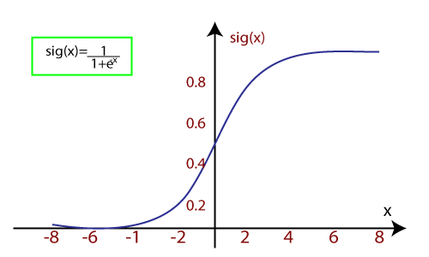
- It uses the concept of threshold levels, values above the threshold level are rounded up to 1, and values below the threshold level are rounded up to 0.
There are three types of logistic regression:
- Binary(0/1, pass/fail)
- Multi(cats, dogs, lions)
- Ordinal(low, medium, high)

Polynomial Regression:
- Polynomial Regression is a type of regression which models the non-linear dataset using a linear model.
- It is similar to multiple linear regression, but it fits a non-linear curve between the value of x and corresponding conditional values of y.
- Suppose there is a dataset which consists of datapoints which are present in a non-linear fashion, so for such case, linear regression will not best fit to those datapoints. To cover such datapoints, we need Polynomial regression.
- In Polynomial regression, the original features are transformed into polynomial features of given degree and then modeled using a linear model. Which means the datapoints are best fitted using a polynomial line.
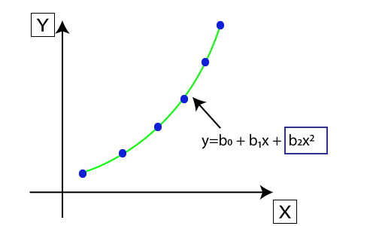
- The equation for polynomial regression also derived from linear regression equation that means Linear regression equation Y= b₀+ b₁x, is transformed into Polynomial regression equation Y= b₀+b₁x+ b₂x²+ b₃x³+.....+ b_{n}x^{n}.
- Here Y is the predicted/target output, b₀, b₁,... b_{n} are the regression coefficients. x is our independent/input variable.
- The model is still linear as the coefficients are still linear with quadratic

Note: This is different from Multiple Linear regression in such a way that in Polynomial regression, a single element has different degrees instead of multiple variables with the same degree.

Introduction to Support Vector Machine (SVM)
Support vector machines (SVMs) are powerful yet flexible supervised machine learning algorithms which are used both for classification and regression. But generally, they are used in classification problems. In 1960s, SVMs were first introduced but later they got refined in 1990. SVMs have their unique way of implementation as compared to other machine learning algorithms. Lately, they are extremely popular because of their ability to handle multiple continuous and categorical variables.
An SVM outputs a map of the sorted data with the margins between the two as far apart as possible. SVMs are used in text categorization, image classification, handwriting recognition and in the sciences.

Working of SVM
An SVM model is basically a representation of different classes in a hyperplane in multidimensional space. The hyperplane will be generated in an iterative manner by SVM so that the error can be minimized. The goal of SVM is to divide the datasets into classes to find a maximum marginal hyperplane (MMH).
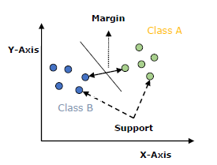
The followings are important concepts in SVM −
- Support Vectors − Datapoints that are closest to the hyperplane is called support vectors. Separating line will be defined with the help of these data points.
- Hyper plane − As we can see in the above diagram, it is a decision plane or space which is divided between a set of objects having different classes.
- Margin − It may be defined as the gap between two lines on the closet data points of different classes. It can be calculated as the perpendicular distance from the line to the support vectors. Large margin is considered as a good margin and small margin is considered as a bad margin.
The main goal of SVM is to divide the datasets into classes to find a maximum marginal
hyper plane (MMH) and it can be done in the following two steps −
- First, SVM will generate hyperplanes iteratively that segregates the classes in best way.
- Then, it will choose the hyperplane that separates the classes correctly.

SVM Kernels
In practice, SVM algorithm is implemented with kernel that transforms an input data space into the required form. SVM uses a technique called the kernel trick in which kernel takes a low dimensional input space and transforms it into a higher dimensional space. In simple words, kernel converts non-separable problems into separable problems by adding more dimensions to it. It makes SVM more powerful, flexible and accurate. The following are some of the types of kernels used by SVM.

Support Vector Regression:
Support Vector Machine is a supervised learning algorithm which can be used for regression as well as classification problems. So if we use it for regression problems, then it is termed as Support Vector Regression.
Support Vector Regression is a regression algorithm which works for continuous variables. Below are some keywords which are used in Support Vector Regression:
- Kernel: It is a function used to map a lower-dimensional data into higher dimensional data.
- Hyperplane: In general SVM, it is a separation line between two classes, but in SVR, it is a line which helps to predict the continuous variables and cover most of the datapoints.
- Boundary line: Boundary lines are the two lines apart from hyperplane, which creates a margin for datapoints.
- Support vectors: Support vectors are the datapoints which are nearest to the hyperplane and opposite class.
In SVR, we always try to determine a hyperplane with a maximum margin, so that maximum number of datapoints are covered in that margin. The main goal of SVR is to consider the maximum datapoints within the boundary lines and the hyperplane (best-fit line) must contain a maximum number of datapoints. Consider the below image:
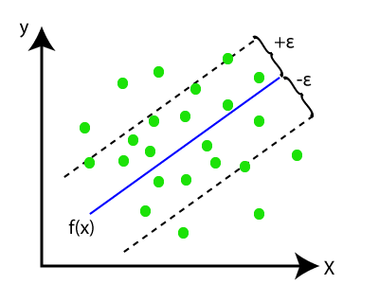
Here, the blue line is called hyperplane, and the other two lines are known as boundary lines.

Decision Tree Regression:
- Decision Tree is a supervised learning algorithm which can be used for solving both classification and regression problems.
- It can solve problems for both categorical and numerical data
- Decision Tree regression builds a tree-like structure in which each internal node represents the "test" for an attribute, each branch represent the result of the test, and each leaf node represents the final decision or result.
- A decision tree is constructed starting from the root node/parent node (dataset), which splits into left and right child nodes (subsets of dataset). These child nodes are further divided into their children node, and themselves become the parent node of those nodes. Consider the below image:
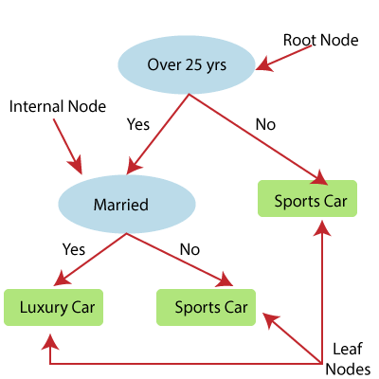
Above image showing the example of Decision Tee regression, here, the model is trying to predict the choice of a person between Sports cars or Luxury car.
- Random forest is one of the most powerful supervised learning algorithms which is capable of performing regression as well as classification tasks.
- The Random Forest regression is an ensemble learning method which combines multiple decision trees and predicts the final output based on the average of each tree output. The combined decision trees are called as base models, and it can be represented more formally as:
g(x)= f₀(x)+ f₁(x)+ f₂(x)+....
- Random forest uses Bagging or Bootstrap Aggregation technique of ensemble learning in which aggregated decision tree runs in parallel and do not interact with each other.
- With the help of Random Forest regression, we can prevent Overfitting in the model by creating random subsets of the dataset.

Decision Tree Classification Algorithm
- Decision Tree is a Supervised learning technique that can be used for both classification and Regression problems, but mostly it is preferred for solving Classification problems. It is a tree-structured classifier, where internal nodes represent the features of a dataset, branches represent the decision rules and each leaf node represents the outcome.
- In a Decision tree, there are two nodes, which are the Decision Node and Leaf Node. Decision nodes are used to make any decision and have multiple branches, whereas Leaf nodes are the output of those decisions and do not contain any further branches.
- The decisions or the test are performed on the basis of features of the given dataset.
- It is a graphical representation for getting all the possible solutions to a problem/decision based on given conditions.
- It is called a decision tree because, similar to a tree, it starts with the root node, which expands on further branches and constructs a tree-like structure.
- In order to build a tree, we use the CART algorithm, which stands for Classification and Regression Tree algorithm.
- A decision tree simply asks a question, and based on the answer (Yes/No), it further split the tree into subtrees.
- Below diagram explains the general structure of a decision tree:

Note: A decision tree can contain categorical data (YES/NO) as well as numeric data.
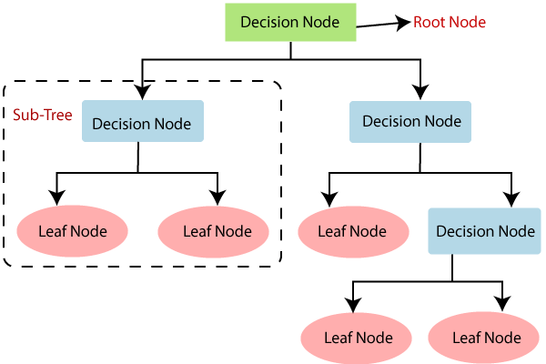

Why use Decision Trees?
There are various algorithms in Machine learning, so choosing the best algorithm for the given dataset and problem is the main point to remember while creating a machine learning model. Below are the two reasons for using the Decision tree:
- Decision Trees usually mimic human thinking ability while making a decision, so it is easy to understand.
- The logic behind the decision tree can be easily understood because it shows a tree-like structure.

Decision Tree Terminologies
• Root Node: Root node is from where the decision tree starts. It represents the entire dataset, which further gets divided into two or more homogeneous sets.
• Leaf Node: Leaf nodes are the final output node, and the tree cannot be segregated further after getting a leaf node.
• Splitting: Splitting is the process of dividing the decision node/root node into sub-nodes according to the given conditions.
• Branch/Sub Tree: A tree formed by splitting the tree.
• Pruning: Pruning is the process of removing the unwanted branches from the tree.
• Parent/Child node: The root node of the tree is called the parent node, and other nodes are called the child nodes.
How does the Decision Tree algorithm Work?
In a decision tree, for predicting the class of the given dataset, the algorithm starts from the root node of the tree. This algorithm compares the values of root attribute with the record (real dataset) attribute and, based on the comparison, follows the branch and jumps to the next node.
For the next node, the algorithm again compares the attribute value with the other sub-nodes and move further. It continues the process until it reaches the leaf node of the tree. The complete process can be better understood using the below algorithm:
- Step-1: Begin the tree with the root node, says S, which contains the complete dataset.
- Step-2: Find the best attribute in the dataset using Attribute Selection Measure (ASM).
- Step-3: Divide the S into subsets that contains possible values for the best attributes.
- Step-4: Generate the decision tree node, which contains the best attribute.
- Step-5: Recursively make new decision trees using the subsets of the dataset created in step -3. Continue this process until a stage is reached where you cannot further classify the nodes and called the final node as a leaf node.
Example: Suppose there is a candidate who has a job offer and wants to decide whether he should accept the offer or Not. So, to solve this problem, the decision tree starts with the root node (Salary attribute by ASM). The root node splits further into the next decision node (distance from the office) and one leaf node based on the corresponding labels. The next decision node further gets split into one decision node (Cab facility) and one leaf node. Finally, the decision node splits into two leaf nodes (Accepted offers and Declined offer). Consider the below diagram:
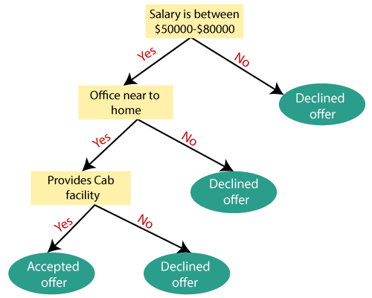

Attribute Selection Measures
While implementing a Decision tree, the main issue arises that how to select the best attribute for the root node and for sub-nodes. So, to solve such problems there is a technique which is called as Attribute selection measure or ASM. By this measurement, we can easily select the best attribute for the nodes of the tree. There are two popular techniques for ASM, which are:
- Information Gain
- Gini Index

1. Information Gain:
- Information gain is the measurement of changes in entropy after the segmentation of a dataset based on an attribute.
- It calculates how much information a feature provides us about a class.
- According to the value of information gain, we split the node and build the decision tree.
- A decision tree algorithm always tries to maximize the value of information gain, and a node/attribute having the highest information gain is split first. It can be calculated using the below formula:

- Information Gain= Entropy(S)- [(Weighted Avg) *Entropy(each feature)
Entropy: Entropy is a metric to measure the impurity in a given attribute. It specifies randomness in data. Entropy can be calculated as:
Entropy(s)= -P(yes)log2 P(yes)- P(no) log2 P(no)
Where,
- S= Total number of samples
- P(yes)= probability of yes
- P(no)= probability of no

2. Gini Index:
- Gini index is a measure of impurity or purity used while creating a decision tree in the CART(Classification and Regression Tree) algorithm.
- An attribute with the low Gini index should be preferred as compared to the high Gini index.
- It only creates binary splits, and the CART algorithm uses the Gini index to create binary splits.
- Gini index can be calculated using the below formula:
Gini Index= 1- ∑_{j}P_{j}²

Pruning: Getting an Optimal Decision tree
Pruning is a process of deleting the unnecessary nodes from a tree in order to get the optimal decision tree.
A too-large tree increases the risk of overfitting, and a small tree may not capture all the important features of the dataset. Therefore, a technique that decreases the size of the learning tree without reducing accuracy is known as Pruning. There are mainly two types of tree pruning technology used:
- Cost Complexity Pruning
- Reduced Error Pruning.

Advantages of the Decision Tree
- It is simple to understand as it follows the same process which a human follow while making any decision in real-life.
- It can be very useful for solving decision-related problems.
- It helps to think about all the possible outcomes for a problem.
- There is less requirement of data cleaning compared to other algorithms.

Disadvantages of the Decision Tree
- The decision tree contains lots of layers, which makes it complex.
- It may have an overfitting issue, which can be resolved using the Random Forest algorithm.
- For more class labels, the computational complexity of the decision tree may increase.

